

DevOps overview & Source Code Management Lab

LAB 1 Assignment

**Name- Ujjwal Kumar Gupta**

**SAP ID- 500091584**

**Batch B1&B2**

1. Create a java project and put it in Local Folder.

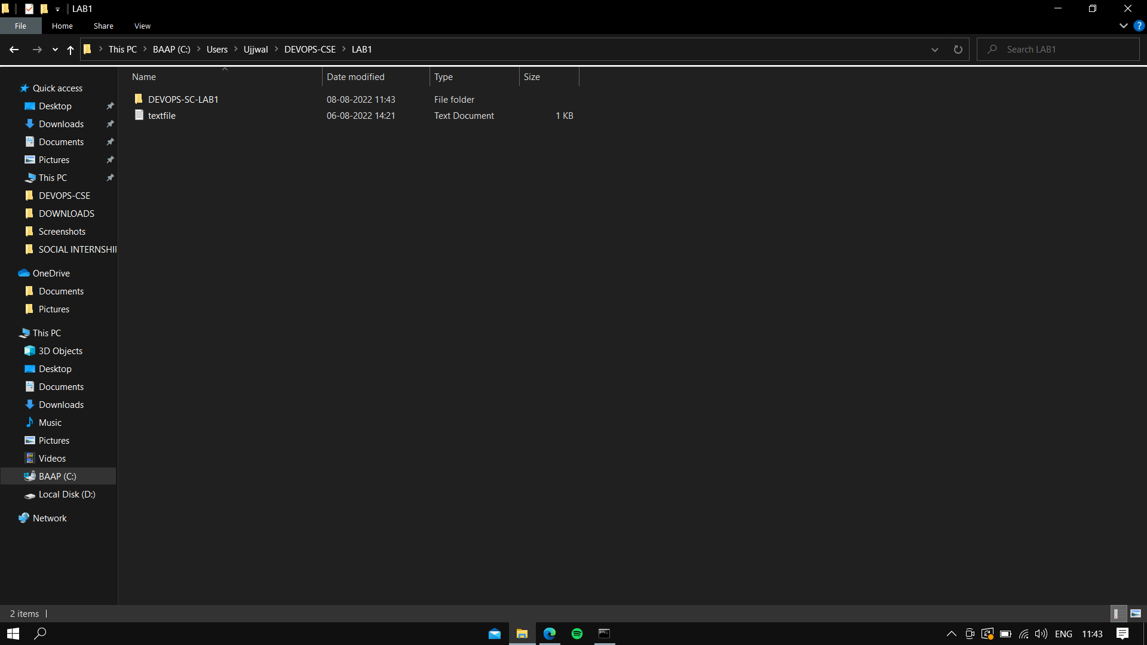

1. Convert it into Git Repo (Local).

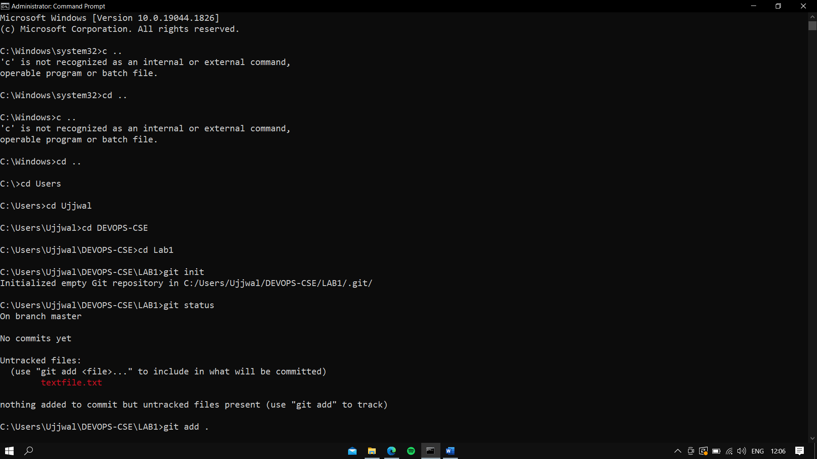

1. Create a Repo on GitHub.

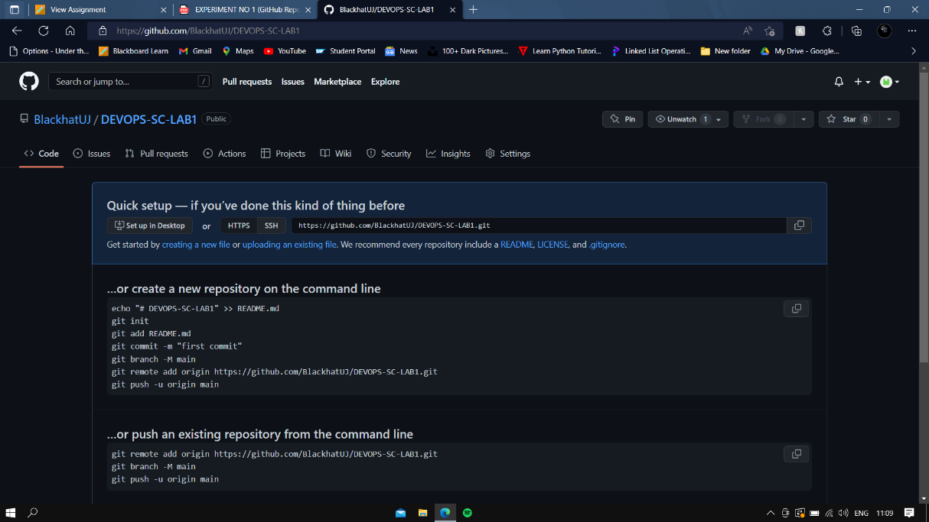

1. Push the Local Repo on GitHub Repo.

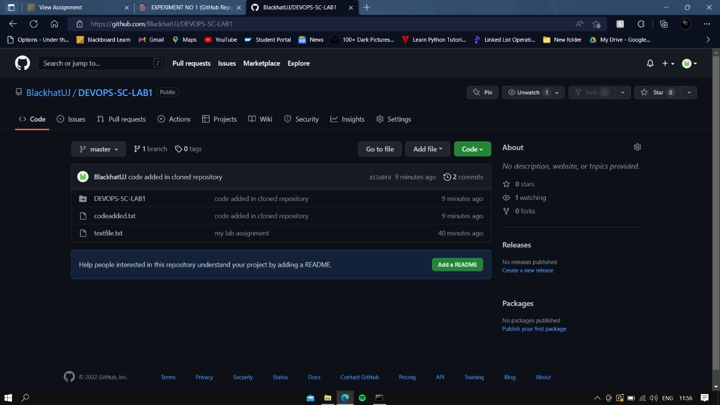

1. Clone the Remote Repo.

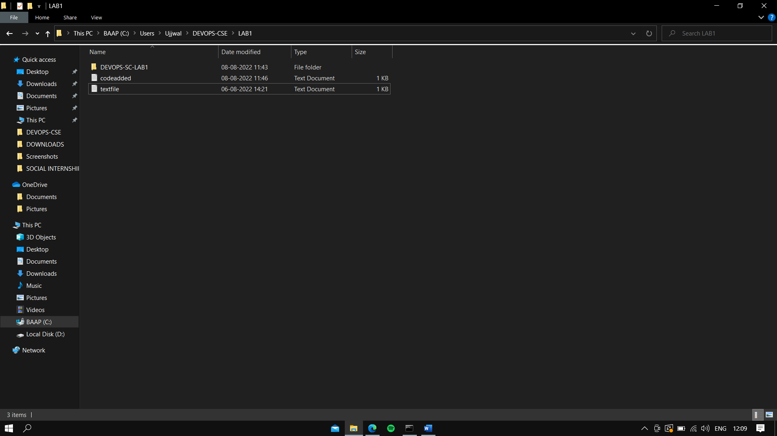

1. Add some code in cloned repo.

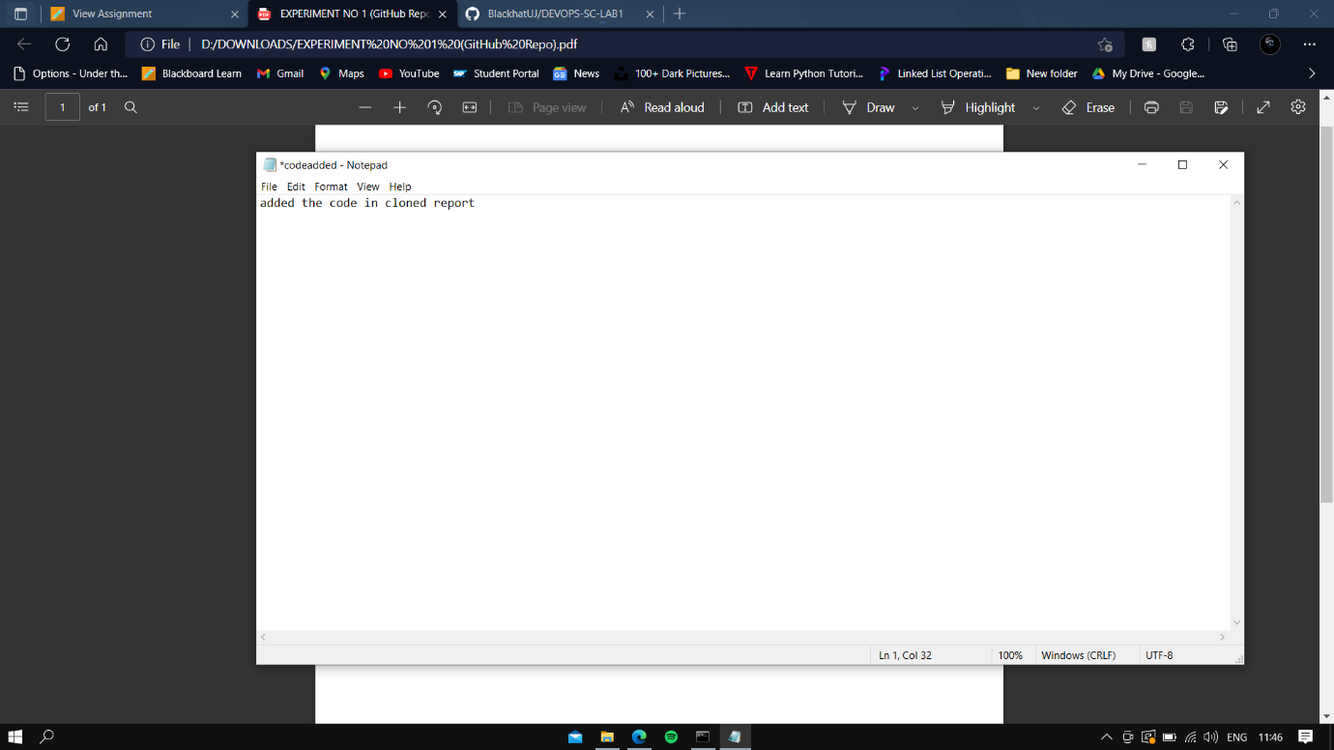

1. Push again the updated local repo on GitHub Remote Repo



**THANK YOU**